Assessing Knowledge in Dialogue:

Synopsis-based Oral Examinations at a Danish Business School

A Paper Submitted for the Education – Instructional Pedagogies Track of the
Academic and Business Research Institute Conference, Nashville 2011

Charles T. Tackney, Ph.D., Associate Professor
Department of Intercultural Communication and Management
Copenhagen Business School
Porcelænshaven 18A
Frederiksberg, Denmark DK-2000
+45-3815-3815, Tel.
+45-3815-3840, Fax.
ct.ikl@cbs.dk, email

Assessing Knowledge in Dialogue:

CEMS Student Experience and Grading Criteria for Synopsis-based Oral Examinations at a Danish Business School

ABSTRACT

This research introduces a local-regional university examination form – the synopsis-based oral examination (S-BOE) - as it is deployed in both large and small international management education programs in Danish tertiary business school education. The S-BOE assesses student achievement in light of specified learning objectives through presentation and dialogue. It is premised on prior submission of a synopsis that is not itself part of the grade assessment. Students experience this examination format as an important learning experience in respect to course-related knowledge issues and a range of interpersonal skills. Exemplary students may evidence a form of “dramatic knowledge” when they creatively display a comprehensive, reflective, and reflexive understanding of course material in presentation and subsequent dialogue. Survey data is reviewed of spring term 2009 CEMS student experience with this examination form. In addition, the epistemological grounds of the current grading system are examined in light of the insight-based critical realism of Bernard J.F. Lonergan, with a view to improving current grading parameters to more accurately reflect and capture the forms of dramatic knowing manifest in this examination.

Keywords: synopsis-based oral examination, management education, curriculum design, dramatic knowledge.

Throughout the world, tertiary education programs face increasing pressures from various sources to rationalize, economize, and offer transparent, internationally “recognized” assessment standards and examination formats. Business schools and management education seem particularly driven by such concerns. Yet, while knowledge is the goal of learning, management and business education apparently remains fundamentally conflicted about the very “nature of knowledge” in business schools and, in consequence, of its appropriate assessment. Chia and Holt (2008) challenged notions of “knowledge-by-representation” and, by implication, ‘objective’ assessment, concluding their paper with the hope that they “have made a case for encouraging a supplementary form of tacit knowledge realized through personal and imaginative habituation” (p. 483). Elsewhere, scholars have taken up study of activities designed to foster development of intuition in management education (Sadler-Smith & Burke, 2007), as well as reflective qualities for management competence (Hedberg, 2009).
This paper offers research seeking to introduce, practically examine, and then offer reflective suggestions about a particular examination form having regional utility in assessments of both explicit and tacit dimensions of personal and imaginative habituation in relation to coursework. The suggestions intend to improve instructor knowledge of and explanations given for grading parameters, which ought to enhance preparatory explanations given to students.
In particular, there are three aims. First, I wish to detail a local or regional undergraduate examination form – the synopsis-based oral examination (S-BOE) - as it is deployed in both large and small international management education programs at a Danish business school (DBS). Attention is particularly paid to the current grading scale and recent modifications regarding learning objectives based curriculum assessment guidelines. Second, we will explore the use of this S-BOE in a 2009 Master’s course, providing background on the CEMS program and student survey outcomes concerning their experience with this examination form. In the third part of the paper, the insight-based critical realism of Bernard J.F.Lonergan is introduced to ground a suggested enhancement of the current grading criteria.
The goal is to help ensure that assessment practices constitute, for both examiner and student, a proper, final assurance of learning outcomes. In addition, there is every reason to look on assessment practices themselves as a contributing and constitutive part of a comprehensive course-learning experience. In this respect, the paper is part of a continuing effort to reflect on the very notion of assessment and to recommend to a broader audience an examination approach that authentically engages the whole person in an intersubjective dialogue.
Because the S-BOE format presents an interesting, arguably unique, opportunity for dialogue and assessment, this paper may aid exploration of the positive dimensions of the ‘hidden curriculum’ in tertiary education. In contrast to the traditional analysis of power and subjugation associated with the phrase and the broader, legitimate analytical agenda it has been associated with (Apple, 2004), this research suggests that an education of merit may derive from educational practices that persist in the global “periphery”: traditional and customary, almost idiosyncratic, educational approaches not known to “mainstream” education research. The processes of internationalization and globalization need not result in abject abandonment of long-standing, traditional teaching practices. These historical processes can, given time, reflection, and collaboration, result in a greater reflexive awareness of the intrinsic merit of teaching practices that are not readily reducible to simplistic notions of “objective” grading standards.

METHOD

This is an extended research essay in three sections with a concluding discussion. The first section provides sufficient information about the S-BOE format for it to be understood and, thus, potentially adaptable to other circumstances. The second section provides a practical grounding of one instance of exam application: a CEMS Master’s course taught in the 2009 spring term. The Global Alliance in Management Education (CEMS) program is introduced. Then, the course description, stated learning objectives, and detailed lesson plan are introduced and referenced in Appendix 1. The course grade distribution is provided in the text, along with summary results of a post-examination survey offered to all students who attended the final exam concerning their experience and perceptions of the S-BO examination.
The final section of the paper returns to the topic of grade assessment in light of student data. The insight-based critical realism of Bernard J.F. Lonergan is briefly introduced. Then, the categories of cognitional operations are applied to the examination format in order to aid instructor examination abilities as well as to offer an account of the examination potential that will improve student understanding of the format and aid grade assessment transparency.

1. The Synopsis-based oral examination

Synopsis-based oral examinations are deployed at DBS in courses “that teach an eclectic mix of theory, method, and empirical content, often with different instructors in same course. In that situation, the opportunity of writing a synopsis enables and inspires the student to work towards creating some coherence across the different perspectives while accepting the legitimacy of differences.” Approximately one-third of all courses at this school use this examination format.
Students compose and submit their course synopses by a specific deadline, usually some days after the end of the last class. Although practices vary by instructors, there are no specific – and certainly no uniform - guidelines regarding synopsis content or format; page length is specified, usually not to exceed a maximum of five double-spaced pages.
Students may compose the synopsis together, as long as each student submits her or his individual synopsis. The synopsis, significantly, has no bearing on the student’s final grade in the oral examination.
Synopsis submission signals staff that the student will be attending the exam. Once submitted, the administrative staff compose an examination list of eligible students, sending the list and synopses to the examiner and censor one to two weeks in advance. In this, the staff function is purely clerical.
Both examiner and censor are expected to have read the synopses prior to examination day. The examiner has usually taught the course. The DBS, a business school that is part of the national university system, deploys censors according to the different Program regulations in accordance with Ministry regulations. The censor is an individual approved by the school or a related educational ministry. The censor’s role is to ensure procedural fairness for both examiner and examinee; internal or external censors are a part of examinations at universities throughout this country. Her or his role is essentially one of observation and recording of the examination exchange. At the examiner’s discretion, the censor may or may not be invited to actively participation in the oral examination discussion.
As previously noted, the grade is formally and entirely based on the oral examination experience alone, in light of the learning objectives for the course. As noted, students may work together in crafting and submitting their separate synopses – even the same text may be submitted by several students. Notably, each student retains the right to ask examiner and censor to disregard the synopsis entirely, should the student decide on reflection - after submission - that what was submitted is not a proper point of departure for the examination.
On examination day, examiner and censor occupy an assigned room with a list of students to be examined. The time allotted for each student is set by the administration; for course-based examinations this time period is currently 20 minutes per student. The 20 minute period includes:
a. a brief oral student presentation, which can be based on the previously submitted synopsis or not, depending on student inclination, and
b. a dialogue, during which time student, examiner and censor engage in a discussion intended to assess student knowledge of course material.
The student is asked to leave the room. The examiner and censor decide on a grade, which is assigned in light of student performance relative to the stated learning objectives for the course. The student is called back to the room for the grade award and a brief discussion of the examination.
This examination format, while very popular at the DBS, apparently did not originate here. Still, it is considered a traditional format and common to the culture and country. In fact, its specific origins, be they domestic or otherwise, remain somewhat murky. Knowledgeable colleagues suggest it may have come from the national university’s psychology, sociology or anthropology departments. Others believe it to be based upon the nation’s high school educational practices. There is, then, an apparently tacit presumption of the culturally given that has “attached” to the S-BOE format. Understandably, exchange students, apparently without exception, experience this exam form as new, strange, and – based on the questions that arise concerning it – rather suspicious: the possibility that the synopsis has no bearing on the final grade is viewed with skepticism the first time through.
However introduced, the S-BOE appears to have found widespread use within the DBS as a result of rationalization efforts. At one time, particularly in language courses, it was common to have an exam that required the instructor to develop several different exam questions. A student would select one, and then spend a period of time, perhaps 30 minutes, to privately prepare this exam question. This required teacher preparation of many questions, a preparation room and a proctor’s watchful compensation. The student would then face an oral examination in the presence of examiner and censor. At the DBS Master’s level, the shift to the S-BOE format, particularly for courses with a “language” component, took place at the end of the 1990s. It is uncertain to what degree, if any, explicit pedagogical and or curriculum theory considerations informed these decisions.
Currently, courses must present clearly formulated learning objectives at the outset. Each learning objective is phrased in a manner consistent with correlated cognitive skills (Biggs & Tang, 2009). These range from simple retention and recitation of facts to the ability to theorize, generalize, hypothesize, and reflect. The national grading criteria are given in Figure 1. There is an implicit progression in cognitive skills in the ordering of stated objectives.
Student grades are determined by the extent to which students evidence these skills against the grade categories. At DBS, grades are assessed only in reference to the stated learning objectives. There is no forced curve distribution. In theory, if all students evidence “an excellent performance, displaying a high level of command of all aspects of the relevant material with no or only a few minor weaknesses,” then every student would earn a grade of 12 (A). In practice, this does not routinely obtain.
The language of the cognitive-skills based learning objectives and grade explanation is wholly directed at the assessment of student performance. This is, of course, as it should be. However, from an intersubjective perspective, the criteria appear to represent a very constrained and restricted ‘view’ of actual student performance, particularly at the higher grade levels.
Thus, while these assessment measures help to provide objective terms and assurance of learning outcomes, they represent minimum threshold normative evaluations of an examination process that is, in fact, dramatically rich and potentially far more rewarding that what the grade assesses or indicates. That said, one recent comment by a former Program Director personally responsible for the conversion of an entire program of course descriptions to learning-based criteria warrants mention. Despite any weakness that may remain in the assessment process, he found the overall curriculum re-design very helpful; “It compelled many of the instructors to figure out what it was that they expected the students to learn from these courses they had been teaching for a long time.”
Returning to the exam format of interest, at its best, the S-BOE is far more than a rote process to assess one individual’s factual knowledge. It involves examiner and censor as collaborative hosts to a student presentation and dialogue that dramatically obliges the student to engage the audience with the student’s presently known, self-understood, and dynamically structured insight(s) into complex course material. Neither presentation nor subsequent dialogue can be totally memorized, prepared, or anticipated. There is a lively discussion of data, facts, history, and theory (often competing and/or complementary) between and among three individuals.
In form, the S-BOE most closely resembles theatre. However, it also goes beyond art education and theatrical constructs of “dramatic knowing” (Rasmussen & Wright, 2001). Rasmussen and Wright state, “In linguistic terms, dramatic knowing highlights a certain intentional, interactive, creative, and context-situated production of meaning.”
In practice, the examiner can be thought to proxy for the informed critic. The censor stands in for the public-at-large. The student, as performer, enacts a role that, while possible to rehearse, invariably becomes challenged, occasionally being overwhelmed, by the sheer set and setting of the examination and its unique intersubjective dynamic.
In function, the S-BOE format is an intersubjective educational encounter consisting of three distinct parties. For undergraduate students, it has a striking impact, as indicated by the informal exchange student comments recorded in December 2008 (Tackney, Sato, Stömgren, 2009). Fundamentally, it is a dramatic intersubjective encounter (Buber, 1971; Lonergan, 1992). And, once this function is apprehended in all its richness, the undersight of the current grading process is starkly revealed. As Rasmussen and Wright wrote, dramatic knowing “tends to be poorly organised outside of the arts curriculum itself.”
Before we attempt to better organize the assessment of such manfest knowing, we will take up a particular CEMS Master’s course and its synopsis-based oral examination from spring 2009. This evidence provides useful detail for the subsequent epistemological exploration.

2. DBS: the CEMS Program, an Elective Course, Grades and Student Survey

DBS receives about 1,000 students annually from over 280 university exchange partners throughout the world. From teaching experience, it is clear that the S-OBE format presents exchange students with a puzzling new examination experience, generating a wide-range of reactions, no small degree of serious concern, and even outright apprehension. Because, the experience of CEMS Master’s students would be of interest for our school’s curriculum reflection and future examination explanations, the author devised a student survey in 2009 when presented with an opportunity to serves as a CEMS elective course censor for the final synopsis-based oral examination.
Of the total number of exchange students to DBS, CEMS exchange graduate students number between 50 and about 90 per year. CEMS is a “global alliance in management education” (CEMS 2011) composed of “academic and corporate institutions dedicated to educating and preparing future generations of international business leaders” (CEMS 2011). Originally a European higher education consortium founded in 1988, it has internationalized to include 26 academic institutions that work together with some 64 corporate partners in offering a Master’s degree in International Management and other cooperative efforts. The DBS joined this alliance two years after establishment. The students in the course of interest were all CEMS graduate students.
The spring 2009 CEMS course was titled, “CEMS Lab: Leadership across Borders.” The course involved case study analysis; the course description and lesson plan are given in Appendix 1. It was expected that the S-BOE format would be a first experience for many, if not all, of the CEMS exchange students.
This was the grade distribution for the course:
Grade (Danish scale) Number of CEMS Students (%) ECTS grade equivalent
12 41 (74.5%) A
10 10 (18.1%) B
7 3 ( 5.5%) C
4 1 ( 1.8%) D
02 0 E (minimal pass)
00 0 Fx (failure)

As mentioned above, grading is given on an absolute basis at DBS. There is no forced distribution. However, grading at this institution is reviewed along with grades from other national institutions. The overall pattern of grade frequencies, over time and at a macro-level, is projected to approximate this normal distribution:
•12 / A: top 10%
•10 / B: next 25%
• 7 / C: next 30%
• 4 / D: next 25%
• 2 / E: bottom 10%
Clearly, this instance of CEMS grade distribution is unusual. Any number of possible explanations may be offered, with CEMS student academic performance levels being one obvious possibility; these students have an academic performance records of the highest caliber. Before considering this variance further, we can now take a look at how these successful students viewed the S-BO examination format.
An on-line survey regarding their perception of the S-BOE format was mentioned to each student at the conclusion of her or his exam – after the grade and discussion time ended. An email invite to participate in the survey was then sent to each student. This email contained a link to the first page of the survey previously created on s survey website. A follow-up email was also sent to the students registered for the course. The survey itself is presented in Appendix 2.
There were 55 students who attended the final examination. Of these, 37 participated in the post-examination survey, for a 67% response rate. The survey is given in Appendix 2. The survey data to be reviewed cannot be considered representative of the class. We did not query students on their individual grade performance. Further, there was no legal way to correlate grade data. Thus, the data and views expressed are only useful in respect to the questions presented on an anecdotal level of particular student opinion and thought.
The survey was completed by the 37 participants between May 20 and June 4, 2009. One respondent skipped answers and was deleted. The average student age was 24.8 years. Eighteen students were male. There were 13 students claiming Danish or Danish and other citizenship. Six were German. The rest of the 36 respondents were individually or pairs: Austrian, Canadian, Czech, Dutch (2), Finnish, French (2), , Hungarian, Italian, Norwegian, Polish, Romanian, Serbian, and Swiss. Of the Danish students, 12 responded to the query regarding years of Danish education; the average was 13 years, with a range between 5 and 25 years. This would indicate a sub-group within the course with probable prior exposure to the S-BOE format.
Twenty-six respondents were “DBS students,” while 10 were not. Curiously, when next queried about school of origin, this list of 13 schools obtained:
Corvinus University of Budapest
RSM Erasmus University (Rotterdam)
University of St.Gallen
RSM Erasmus University (Rotterdam)
The University of Economics in Prague
London School of Economics
University of St. Gallen
Warsaw School of Economics
Austria
London School of Economics
The University of Economics, Prague
Uni St. Gallen
WU Vienna

Fourteen students noted that their school does not offer S-BOEs. Two offered the following comments: “Love them” and “I think it is a very good tool which helps in starting a discussion at the exam.” The first comment refers to the exam format, while the latter is a reflection on the function of the synopsis itself. More specific to the particular examination, 14 students reported this CEMS course was their first S-BOE experience.
Did the students “believe” that the synopsis had no bearing on the final grade before the exam itself? Two replied “Definitely not” and five “Absolutely yes.” Most – 20 of 32 respondents – were not sure either way. One student noted, “I believe the quality of the synopsis does change the initial perception of the student.”
After exam, eight students believed that the synopsis had no bearing on the grade outcome, while three were absolutely sure it did (Q10). Most of the students remained unsure, either way. Comments reflected knowledge that the synopsis framed the initial questions, with one student noting that s/he was told a synopsis in a different exam was “really bad,” yet the student received a 12 (A). Another student expressed uncertainty, noting that teachers get impressions from the synopsis and this must inform their “expectations when meeting the student”.
Question 11 took up what the students thought about the function of the synopsis, if it had no formal bearing on the grade outcome. There were 25 responses, each of which was so interesting that they are presented, verbatim, in Table 1. While one student succinctly noted, “None.”, the rest saw the synopsis as a course reflection and exam organizational tool.
Question 12 returned to student perception of synopsis function, replacing “believe” with “think”. Even with the intervening question of utility, the distribution of responses was the same. This one comment was given; “no idea. still think that influences something in the way how teachers see you.” Curiously, the repetition of this question was a simple editing oversight – there was no survey design intent to revisit this.
Twenty-eight of 32 respondents thought that an individual can become better at taking this type of exam. Those with long prior experience cited this as the reason for their performance success. Most felt the exam format was a learnable skill. Some students thought that an outgoing character was an performance benefit. There was this view from one apparent S-BOE veteran; “it is always challenging to think about the content of the synopsis what to include and what not- what to leave out as a "surprise" element for the oral ;).” Fully 16 of 19 respondents felt that they had become better at S-BOE performance as a function of prior experience. Comments generally took up increased personal confidence in verbal organization and self-expression. One student noted that the key was to focus on discussing and reflecting course material, not simply describing it. Another commented, “more sure of myself in presentations... good practice to have to start a meeting.”
Half of the 32 responding students felt the learning objectives were appropriate as a grading basis. One student offered the following; “It was positive and in a way comforting to know EXACTLY what was expected. However, there might be a risk that the outcome of the course is evaluated - especially by the student - in very absolute terms according to the learning objectives.” Most of the 32 respondents felt the S-BOE permitted “an adequate and appropriate assessment of the learning objectives” (Q16). One student selected “Definitely not.” One comment was “Too easy to bullshit your way out.” Another reply offered a different view; “As there were two assessors present, I expect nothing less, but it is without doubt a challenge to cover/check all learning objectives during a 15 minutes discussion.” One student wrote to the circumstance of misunderstanding, when the correct answer has been given, but to a question different from what the examiner was actually seeking.
Question 17 in the survey concerned student perception of the explicit skills the S-BOE format requires excellence in. Each student’s response is given in Table 2. Respondent 15 has aptly summarized the other views in four words: analysis, coordination, structuring, and communication. From the other responses, these terms seem to suggest:
Analysis: a thorough knowledge and self-appropriation of course materials,
Coordination: this knowledge present in an active framework of thought,
Structuring: reflecting an ordered comprehension,
Communication: and manifest in proper dialogue with examiner.
The next two questions concerned tacit skills associated with this exam form and whether or not the exam aided students in the acquisition of these skills. Specific student responses are listed in Table 3, with far fewer students responding to the stated query: “What, if any, particular tacit skill(s) do you think this test requires excellence in?” Fully 25 students skipped the question, with only 12 taking it up. Overall, self-confidence and interpersonal communications skills prevailed as ‘tacit skills’ required for success. Two noted, the “ability to play with concepts” and “making analyses across the cases.” In contrast, two negative comments were present. One student reported “None”; the other felt the course lacked theory, rendering the exam superficial, and this prevented her/him from going “deep down” into theory about leadership. Eleven students responded to the next question, which concerned whether or not the S-BOE format helped a student gain such tacit skills. Nine responded affirmatively, two negatively. There were three students among the nine who went further than a simple “Yes,” to write “Definitely.”
The final two questions concerned the perceived role of the examination censor. In the main, the responses indicated student awareness of their role to ensure fairness in exam process for both examiner and examinee.
To conclude this review of the student survey, opinion, and reflection, it would appear that while one or two students seemed less than impressed with the format, most found the S-BOE an interesting approach to the assessment of knowledge. They clearly linked the manifestation of this knowledge with the interpersonal manner in which it was presented and discussed. Finally, student apprehension, in all senses of this word, about the role of the synopsis appears to have diminished after an actual experience of the synopsis-based oral examination. And, given the positively skewed distribution of formal grade outcomes and the subjective experiences reported by CEMS students, the nature of that ‘dramatic knowledge’ reportedly manifest in this exam format can now be more closely analyzed.

3. Assessing evidence of dramatic knowledge: insight-based critical realism and the levels of cognitional operation.

An analysis of manifest “dramatic knowledge” for educational assessment requires an exploration of epistemology: the theory of knowledge. Bernard J.F. Lonergan's insight-based critical realism offers useful categories to assess student performance in the synopsis - based oral exams we have been discussing, particularly at the levels of our specific interest.
The point of departure for Lonergan’s theory of knowledge is to be found in reflection upon insight. And, to be clear, insight is nothing more than that moment of ‘seeing into’ connections between notions, “getting the point,” or grasping the point of what one has been struggling to understand.
Reflection on the features of such moments reveals that insight:
1. comes as a release from the tension of inquiry,
2. comes suddenly and unexpectedly,
3. is a function not of outer circumstances but inner conditions,
4. pivots between the concrete and the abstract, and
5. passes into the habitual texture of one’s mind (Lonergan, 1992) (pp. 3-4).
From reflection on the fact of insight, critical realism offers a systematic means to conduct a fine-grain assessment of intentional consciousness or cognitional operations. Experience, inquiry, reflection, and deliberation lead directly to direct insight and concept, reflective insight and judgment, and deliberative insight, evaluation, and choice. As Michael Vertin explained, “It’s really that sensation (or, more broadly, experience) plus inquiry lead to direct insight and formulation (on level 2); those plus reflection lead to reflective insight and judgment (on level 3); and those plus deliberation lead to deliberative insight, evaluation, and choice (on level 4)”.
In Chapter 10 of Insight, Lonergan schematically presented, “three levels of cognitional process.” The third level was either expanded or nuanced into four aspects of cognitional operations in his later Method in Theology (Lonergan 1999, Vertin, 1995):
I. Immediate experience: data, perceptual images, feelings, free images, utterances
- The giveness of being and the unrestricted desire to know.
II. Questions for intelligence: insight and formulation
- Inquiry as mode of questioning: what, why, when, and how often?
- The basic operational dynamism: the transcendental notion of intelligibility.
III. Reflective insight: questions for reflection, leading to judgment
- Reflection as questioning mode: Is it? Is this real? Is that really so?)
- The basic operational dynamism: the transcendental notion of reality
IV. Deliberative insight: questions concerning value-related deliberation.
- Deliberation as the questioning mode: Is it good? Ought that be so?)
- The basic operational dynamism: the transcendental notion of valuability
Following Vertin (1995), levels two through four can generally be taken to “presuppose and complement” each earlier level. This approach is wholly consistent with the learning objectives based grading criteria previously outlined. That is, a student’s sheer physical presence can be rewarded by attendance constituting a per cent of her or his final grade. As it happens, the DBS does not allow course grades to be calculated in reference to attendance or class participation. Moving up the ‘ladder’ of cognitional operations, in the context of a S-BOE format, the simple recitation of course ‘facts’ will count for something, indeed, but far more is expected for a very successful outcome. Evidence of creative engagement with course material can be operative – and evident in oral examinations - at each of the cognitional levels of operation described above.
That said, experience on the first level is immediate – involving sensory experience. Sensation is a particular kind of act; “conscious experience is merely self-present, not self-constitutive” (Ibid., p. 226). Consciousness, in contrast, is a dimension (the experience of self-presence) of every kind of act. Lonergan specifies three components of consciousness that unite in the fourth level and are involved with judgments of value:
1. knowledge of reality and especially of human reality,
2. intentional responses to values, and
3. the initial thrust towards moral self-transcendance constituted by the judgment of value itself. (Lonergan, 1997, p. 38).
We can note other common features of these cognitional stages. In stages two through four, inquiry involves “some supra-experienceable unity in diversity” (Vertin, op. cit., p. 230). In level three, the prospective judgment – the insight of higher order unity - concerns one of fact. At the next level, this judgment concerns one of value. For those involved in management and organization studies, this would be the level of assessment involving the quality of insight and subsequent deliberation that yields to judgments in respect to, for example, specific policy proposals derived from careful weighing of theoretical evidence.

DISCUSSION

The intention behind this research was simple: to try and make more explicit – for students no less than faculty – the cognitive operations involved in the higher levels of inquiry that functionally come to constitute the highest grade level performance that can be achieved in synopsis-based oral examinations. For the practiced examiner and censor, the utility of these epistemological categories should be immediately apparent. In one sense, filling out, or attempting to better describe, the epistemological content of a “dramatic knowledge” performance may appear to be outlining an “ideal type”. Certainly there are examinations that barely rise above examiner and censor confirmation that some facts have been learned, but little more.
However, nothing is more difficult than trying to explain to a student why he or she received a low grade due to poor performance: “I thought I knew all the theories, I explained all the facts. Why didn’t I get a 12 / A?” Explaining normative functional insufficiencies after the exam grade given - that personal insight and judgmental sophistication were absent or lacking –may leave the student feeling the exam was simply unfair. This is particularly the case for students who, for whatever reason, failed to manifest those higher levels of cognitional operation during the course of this fast oral examination process.
So, in the first instance, this paper may aid instructors and censors in their own reflective understanding of how they arrive at grade determinations. Second, students can be appraised early in a course of the levels of course knowledge possible and how these may be successfully manifest during the exam period. Third, should an exam performance not rise to the level of a 12 / A, the “gap” or “gaps” between actual and possible performance may be more readily, and directly, explained.
To that end, an early lecture on these epistemological categories may be helpful for students facing the S-BOE format for the first time. In addition, the presentation of guidelines for a successful examination outcome may be helpful. These guidelines may include the following:

Synopsis-based oral examination guidelines
In this examination format, a successful instructor recognizes student performance that, in light of stated learning objectives:
- Creatively organizes course material and presents personal insights regarding course in a comprehensive and engaging manner.
- Maintains a proactive time-sense throughout exam, sensibly “managing” examiner and censor interruptions, query, and challenges.
- Actively listens to examiner and censor questions or comments, responding with appropriate references to the data, facts, history and theory that constituted course materials.
- Engages in dialogue with examiner and censor in such a manner that all participants authentically act and respond to each other in an equality of course material knowledge, notional discourse, agreement and/or respectful disagreement.
- Introduces extra-course material in a manner that raises the level of the entire examination experience for all participants. Note: while this is not necessary for the highest grade, it may help to ensure one.
Finally, in instances when grade outcomes are unexpectedly and uniformly skewed – either low or high – these categories of cognitional operation may serve as a useful aid in future refinement of the stated learning objectives. This is an oblique way of stating that the categories of cognitional operation aid reflection on how to “upscale” one set of learning objectives to a higher level. Should grades be uniformly low, these same categories offer an analytical tool to consider refinements in learning objectives that should result in better grade performance.
Although the number of respondents was small, students clearly perceived the need for a range of tacit skills for success with this exam format. Thus, continuing, representative, and larger studies of student experience are needed to more thoroughly validate and further explore these findings.
Most significant, perhaps, is that the students felt the specified tactic skills could be learned from the examination format experience itself. In this way, the S-BOE format becomes the final step in the overall course learning experience, and one far different from multiple-choice or written examinations.
Because the S-BOE format presents an interesting, arguably unique, opportunity for dialogue and assessment, this paper may aid exploration of the positive dimensions of the ‘hidden curriculum’ in tertiary education. Traditional analysis of power and subjugation associated with notions of “hidden curriculum,” this exam format study points to other, more positive skilling outcomes that can obtain from careful curriculum design. In the instance, this study may indicate factors of educational merit may be found in the “periphery” of traditional and customary practices, even idiosyncratic educational approaches not known to “mainstream” education research.
The processes of internationalization and globalization need not only result in an ultimate uniformity. Careful reflection on the nature and significance of historical processes that give rise to curriculum practice can, given time, reflection, and collaboration, result in a greater reflexive awareness of overlooked or presumed intrinsic merit. Though this process, valuable teaching practices can be successfully adapted, practices not – at first sight - readily reducible to simplistic notions of ‘objective grading standards’. This paper offers one example.

REFERENCES
Apple, M.W. 2004 Ideology and Curriculum, New York: RoutledgeFalmer.
Biggs, J. & Tang, C. (2009). Teaching for Quality Learning at University. Berkshire: Open University Press.
CEMS (2011). http://www.cems.org/ , accessed February 2, 2011.
Chia, R. & Holt, R. (2008). The Nature of Knowledge in Business Schools. Academy of Management Learning and Education, 7, 471-486.
Hedberg, P. R. (2009). Learning Through Reflective Classroom Practice: Applications to Educate the Reflective Manager. Journal of Management Education, 33.
Lonergan, B. J. F. (1992). Insight. Toronto: University of Toronto Press.
Lonergan, B. J. F. (1999). Method in Theology. Toronto: University of Toronto Press.
Sadler-Smith, E. & Burke, L. A. (2007). Fostering Intuition in Management Education: Activities and Resources. Journal of Management Education, 33.
Tackney, Charles T., Sato, Toyoko, and Ole Strömgren (August 2009). Assessing Knowledge in Dialogue: Undergraduate Synopsis-based Oral Examinations at a Scandinavian Business School. Paper presented at the Management Education Division, Academy of Management conference, Chicago.
Vertin, M (1995). Judgments of value, for the later Lonergan. Method, 13: 221-248.

Figure 1: The DBS and Nation-wide Grading Scale

The Grading Scale (from autumn 2007). Understanding Marks Given According to the Grading Scale: When attempting to understand the value of marks given in the system of another country, it is important not to automatically assume that the practice is similar to your own familiar system. While some systems use a fixed distribution curve and expect all classes to fall within that curve, others specify the level of performance necessary for each mark. Grades in this country for each student are based on his or her specific level of performance; therefore "grading on the curve" is not a valid structure used at DBS.

In this country, where education at all levels, including higher education, is regulated by the Ministry of Education, the marking scale and its use is described in a ministerial order which gives the following overview of the scale:
Grade Mark | Explanation of the Mark | Equivalent ECTS Mark
12 | Is given for an excellent performance, displaying a high level of command of all aspects of the relevant material with no or only a few minor weaknesses | A
10 | Is given for a very good performance, displaying a high level of command of most aspects of the relevant material with only minor weaknesses | B
7 | Is given for a good performance, displaying good command of the relevant material and some weaknesses | C
4 | Is given for a fair performance, displaying some command of the relevant material but also some weaknesses | D
02 | Is given for a performance meeting only the minimum requirements for acceptance  (Lowest passing grade) | E
00 | Is given for a performance which does not meet the minimum requirements for acceptance  (Failure) | Fx
-3 | Is given for a performance which is unacceptable in all respects  (Failure) | F
The participation of external examiners from other institutions in almost all exams contributes to the stability of the scale and should prevent individual interpretation bias in marks.
Note: From the DBS International Office website. Specific school and nation references have been modified or deleted.

Table 1: CEMS Student Survey Responses
Question 11: If the synopsis has no bearing on the grade, what function did it have for you?
(All comments to question are given.)
1. Defining the scope of the examination - creating an agenda.
2. to outline what i wanted to talk about
3. It made me structure my thoughts and gave me a strating point for my arguments for the actual exam.
4. Good summary to getting started with the topic, but was not addressed during the oral exam, so the value of it is limited.
5. Structure your thoughts and create a focus for the exam.
6. To provide me the list of questions or topics that I wanted to raise during my exam
7. It helped me to set a starting point for the exam.
8. 1). In this course I used my the synopsis to refresh, categorize and reflect over the issues and cases that had been discussed during the course. 2). To create a framework that I could use as support during my exam.
9. provided me with a basis for argumentation
10. No function. I talked about something completely different in my 2 minute presentation
11. It helped structure the information beforehand.
12. Focus my thoughts
13. to structure the content of the class and thinking through what i want to talk during the exam
14. Gave a starting point for the discussion and helped structuring the ideas.
15. It was the first step towards building a true, integrated and concise understanding of the course.
16. To organise my thoughts
17. Show some basic discussions to pick up on in the exam. Define what topics that I find most interesting
18. It was a way for me to structure my thoughts and start reading for the exam
19. Offered a structured way of presenting the concepts from the cases and their links to the cases presented.
20. It helped me to structure my own thoughts and to be able to start a discussion at the exam, on a topic which I was interested in
21. reflect on the most important points for me personally
22. Additional work. i don't feel value added from the synopsis, as still similar topics are taken in the exam and presentation could work as synopsis or can overlap, thus sometimes even synopsis are disturbing.
23. to form the content for my examination.
24. None
25. Served as a starting point and set the scene for the discussion.

Table 2: CEMS Student Survey Responses
Question 17: What particular explicit skill(s) do you think this test requires excellence in?
(All comments to question are given.)
1. argumentation and logic of thought
2. in being structured
3. Reflexion, ability to see the overall picture, the connection between the cases
4. Interpersonal, presentation, self-confidence, argumentation, debate and dialogue.
5. Speaking
6. You have to appear confident, talkative, and dont stess over questions that you do not immediately know the answer for.
7. Preparation and rehearsal of presenting the synopsis. Focusing on analysis and reflection and NOT on description
8. thorough knowledge of the topics covered as well as additional knowledge not covered in the syllabus..ability to argue consistently and correctly..
9. communication and expression skills
10. Talking and sounding intelligent.
11. I believe it requires synthesizing skills, abilities to structure a thought, and oral skills
12. communication, organization
13. presentation, argumentation
14. presenting yourself as being able to discuss with teacher, seeing things from different sides etc.
15. Analysing, coordination, structuring, communication
16. Being talkative and able to argue for your own ideas even when the professor or the censor don't seem to share the same point of view
17. analytical thinking and getting to the point
18. delivering message orally, presentation skills, plus knowledge of subject, confidence
19. Presentation skills mostly, how to be logical in your argumentation, structure ability, be able to trust your 'hard disk'
20. none
21. Presentation and discussion skills. The student has to have thought his/her arguments through before entering the room.

Table 3: CEMS Student Survey Responses
Question 18: What, if any, particular tacit skill(s) do you think this test requires excellence in?
(All comments to question are given.)
1. Self-confidence, clear structuring of a verbal presentation, crating links between topics before during and after putting them forth.
2. Interpersonal skills
3. How to start a discussion; determine the problem area. Argumentation skills - how to lead a conversation, and not take a counter-argument as a defeat in a stressed situation.
4. The ability to always question and look further into things
5. ability to play with concepts
6. making analyses across the cases
7. self confidence, personal presentation
8. Understanding the case method, and applying it to the cases studied
9. delivering message orally, presentation skills, plus knowledge of subject, confidence
10. How to be open to other people, listening and answering what you're asked, and sticking to your subject without being too persistent, being able to defend your standpoint.
11. None
12. The lack of theory in the course made the exam somehow superficial and did not give me an opportunity to deep down in theory regarding leadership.

Appendix 1: The CEMS Course Description and Lesson Plan

CEMS LAB- Leadership Across Borders
Course Coordinator EK

Prerequisite/progression of the course
Bachelor degree. The course is offered as core course in the CEMS MIM degree program. The course is only open to CEMS students.

Schedule – subject to change
Week 6: Tuesday, 14:25 – 17.00
Weeks 7-14 & 16-17: Thursday 14:25 – 17:00

Exam date(s)
Week 20: Tuesday, May 12 – Friday, May 15 (this is the exam period for this class – each student will be examined on one of these days)

Course content
Leadership Across Borders offers CEMS students an extended opportunity for practical discussion and critical analysis of the relationship between leadership and management in an ever more global and organizationally diverse environment. In the course, students and faculty will examine and discuss an array of case studies chosen to exemplify the complex strategic, organizational and interpersonal dynamics of leading and managing across national and cultural borders on a day-to-day basis. The intention behind the case-based approach is that CEMS students also develop awareness of and discuss what leadership means for them, and how they will develop as leaders.
The course will also address the methodological issues raised by the use of the case method for learning about the interrelated dynamics of leadership and management, and provide participants with the opportunity to develop effective skills in case discussion, analysis, and presentation.
Themes covered in cases will include: intercultural aspects of strategy formation and marketing across cultures; the management of corporate culture in an international environment; the intercultural dynamics of international management; the management of conflict in intercultural situations; the role of national culture in management and business decisions; managing cultural diversity; team dynamics in global contexts; leadership; gender; discrimination; and managing change in intercultural organizations.

Learning Objectives
At the end of the course students should be able to:
• Explain the logic behind the case method of teaching, and define the central elements of effective case analysis, presentation, and discussion.
• Present effective summary introductions of cases assigned in the course, and explain the components of effective case presentations, as well as the importance thereof.
• Analyze the cases assigned, and individual elements of those cases, from multiple perspectives,
and explain the assumptions behind those multiple perspectives.
• Use the case materials assigned in the course to support multiple definitions of the concept of leadership, and to present practical examples of the multiple ways in which the notion of leadership, as well as particular leadership styles and approaches, compare across organizational, industrial, regional, and cultural boundaries.
• Use the case materials assigned in the course to provide concrete examples of effective (and ineffective) approaches to leadership in a variety of organizational, international, and regional situations.
• Use the case materials assigned in the course to address key debates in the academic research on leadership, including debates over the relationship between leadership and management; debates over the individual, trait-based or social and distributed nature of leadership; debates over the similarities and differences between leadership practices and styles across organizations, regions, and cultures; and debates over the effects of leadership on organizational performance provide concrete examples of how intercultural dynamics and conflicts intersect and intertwine with interpersonal, team, organizational, and strategic dynamics in a variety of different global business settings.

Teaching methods
Class time will consist almost entirely of case-based discussions, with very few formal lectures, and with students actively involved in presenting and analyzing cases. Students will be strongly encouraged to form study groups that meet outside of class to prepare and discuss cases in advance.

Examination
Individual oral examination on all material covered in the course, based on a 3-page written synopsis to be handed in two weeks before the exam. The content of the synopsis is chosen by the student. It is not graded and may be written with one or two fellow students, and it serves as a starting point for the discussion. Duration including marking: 20 minutes.

Course literature
Course materials consist exclusively of business cases. All students are responsible for purchasing all course materials and for showing up for class ready to discuss them. The cases assigned for this course are available for purchase at the Harvard Business School Publishing Website

CLASS SCHEDULE – subject to change

1. Tuesday, February 3, 2009
William Ellet (2007) “How to Discuss a Case,” in The Case Study Handbook: How to Read, Discuss, and Write Persuasively About Cases. Harvard Business School Press: 1-13;
Thomas Green: Power, Politics and a Career in Crisis, Harvard Business School Case Study, 2008
Jonah Creighton (A), Harvard Business School Case Study, 1991

2. Thursday, February 12, 2009
Henry Tam and the MGI Team, by Jeffrey T. Polzer, Ingrid Vargas, Hillary Anger Elfenbein. Harvard Business School Case Study, 2003 .

3. Thursday, February 19, 2009
Lisa Benton (A) + (B), Harvard Business School Case Study, 1994

4. Thursday, February 26, 2009
Ellen Moore (A): Living and Working in Bahrain, by Henry W. Lane, Gail Ellement, Martha L. Maznevskir, Harvard Business School Case Study, 1990.
Ellen Moore (A): Living and Working in Korea; Harvard Business School Case Study, 1997.

5. Thursday, March 5, 2009
Marimekko, by Alison Konrad, Jordan Mitchell, Harvard Business School Case Study, 2007.
Gianna Angelopoulos-Daskalaki and the 2004 Athens Olympic Games A and B, by Chris Marquis, Doug Guthrie, Yannis Katsarakis, Harvard Business School Case Study, 2006.

6. Thursday, March 12, 2009
Deloitte & Touche (A): A Hole in the Pipeline, Harvard Business School Case Study, 1999
Deloitte & Touche (B): A Hole in the Pipeline, Harvard Business School Case Study, 1999

7. Thursday, March 19, 2009
Acer, Inc.: Taiwan's Rampaging Dragon; Bartlett, Christopher A.;St. George, Anthony; Harvard Business School Case Study; 1998; Acer America: Development of the Aspire, by Christopher A. Bartlett, Anthony St. George. Harvard Business School Case Study, 2001

8. Thursday, March 26, 2009
Rudi Gassner and the Executive Committee of BMG International (A) Linda A. Hill, Katherine S. Weber. Harvard Business School Case Study, 1993.

9. Thursday, April 2, 2009
Merck Sharp & Dohme Argentina, Inc. (A) by Lynn Sharp Paine , Harold F. Hogan Jr. Harvard Business School Case Study

10. Thursday, April 16, 2009
Idalene F. Kesner (2003) “Leadership Development: Perk or Priority? (HBR Case Study)” Harvard Business Review. May 1, 2003;
Leadership Development at Goldman Sachs by Boris Groysberg , Scott Snook , David Lane. Harvard Business School Case Study, 2005.
Coaching at Banco Azucarero de Cali (BAC) A and B by Pablo Cardona , Jose Ramon Pin , German Serrano Duarte , Lourdes Susaeta. IESE Business School Case Study, 2004.

11. Thursday, April 23, 2009
In the Shadow of the City, by Anne Donnellon, James Reed, Nicholas Richardson, Harvard Business School Case Study, 1990.

Appendix 2: The On-line CEMS Course S-BOE Survey

p. 1 of 4:

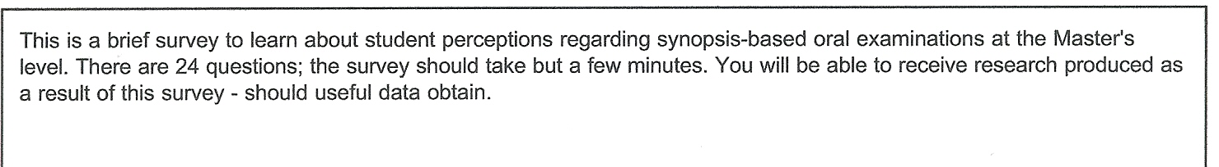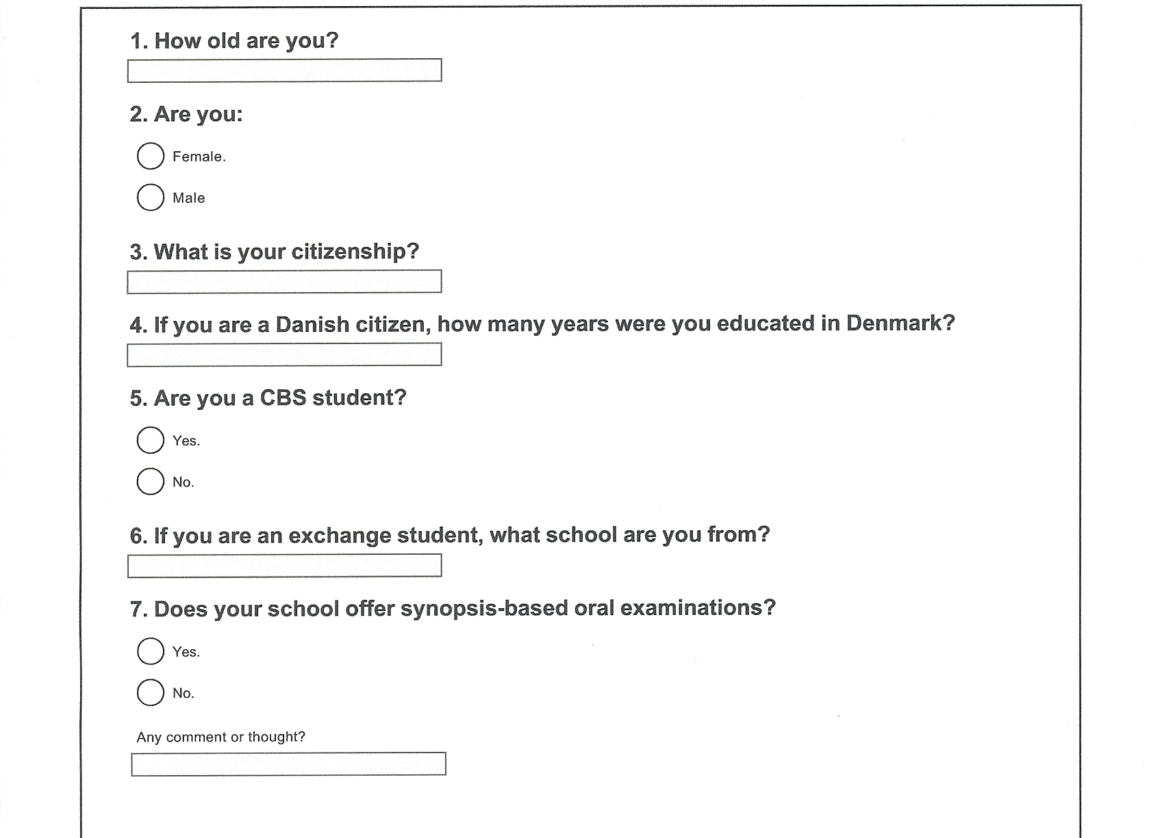

Appendix 2, p. 2 of 4:
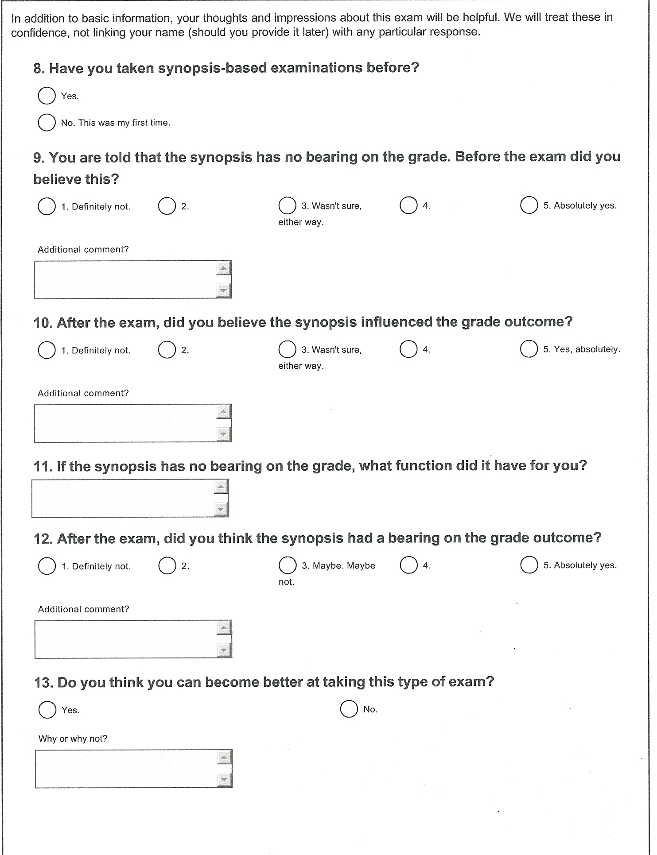

Appendix 2, p. 3 of 4:

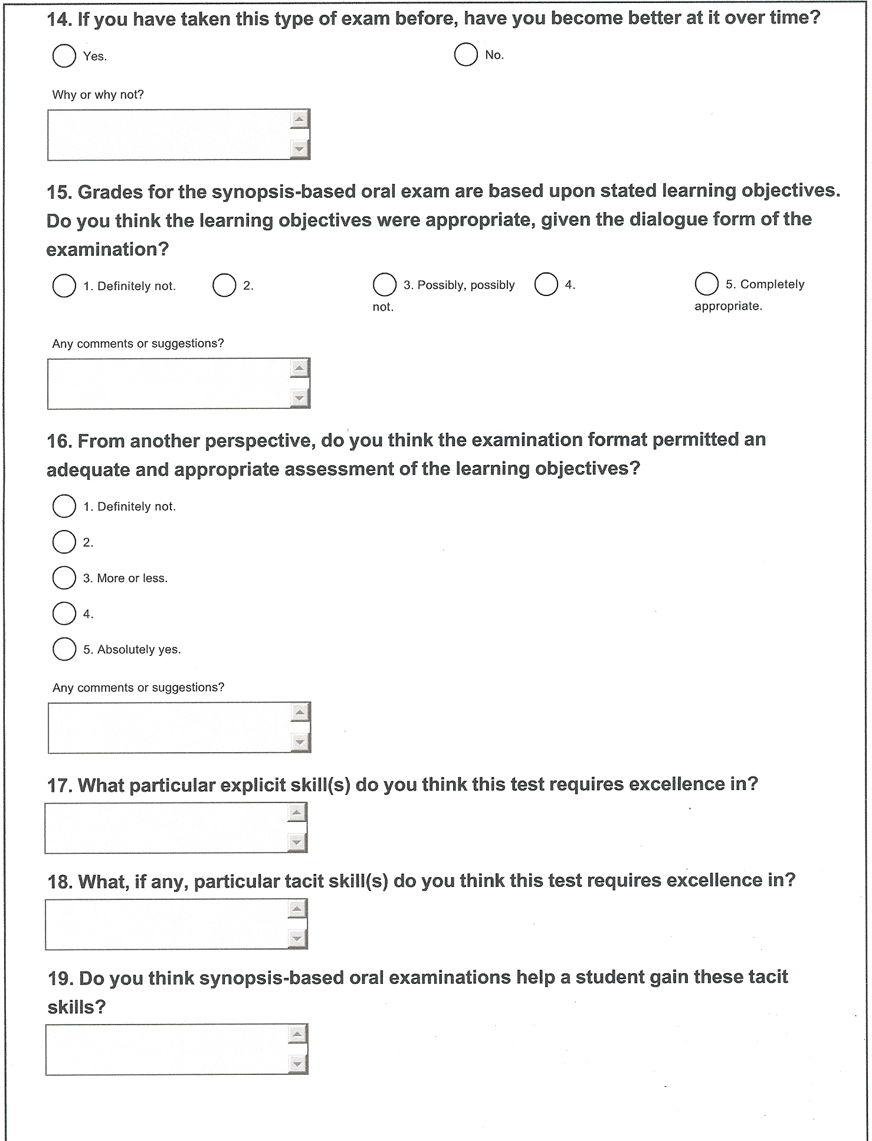

Appendix 2, p. 4 of 4:
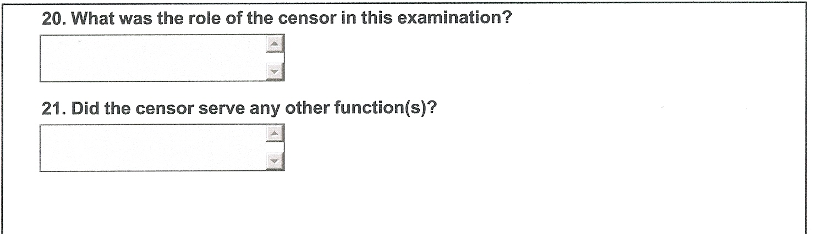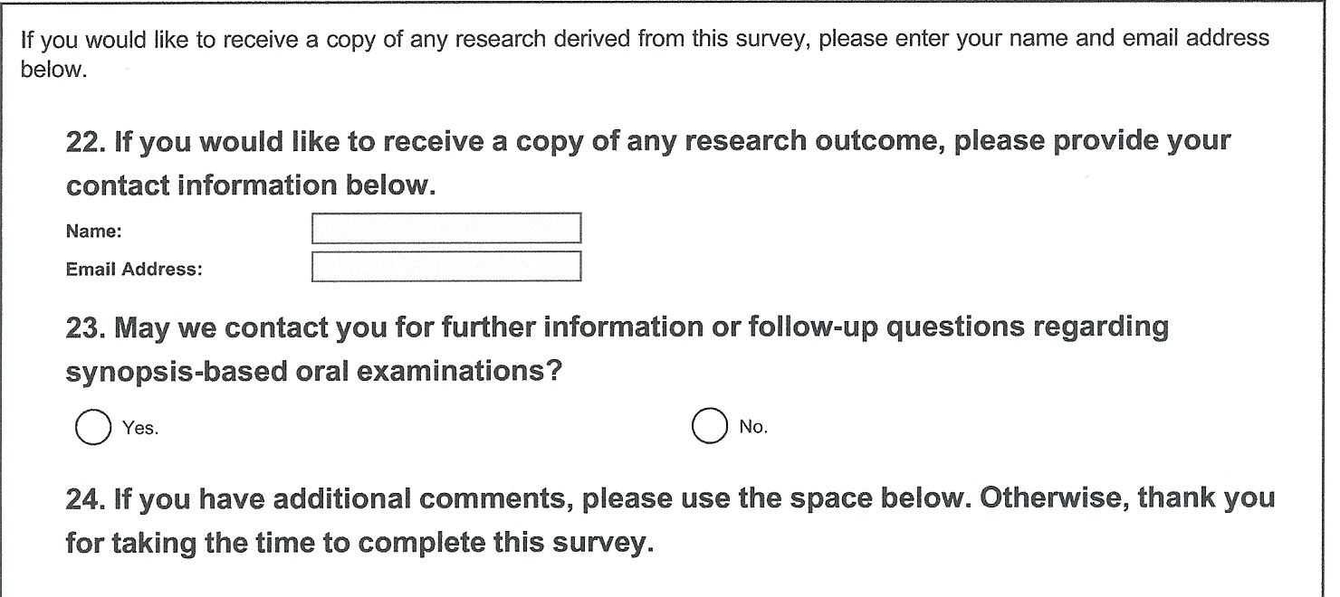

Appendix 3: Intersubjective Student Performance Dimensions in Synopsis-based Oral Examinations

In this examination format, a successful instructor recognizes student performance that, in light of stated learning objectives:
- Creatively organizes course material and presents personal insights regarding course in a comprehensive and engaging manner.
- Maintains a proactive time-sense throughout exam, sensibly “managing” examiner and censor interruptions, query, and challenges.
- Actively listens to examiner and censor questions or comments, responding with appropriate references to the data, facts, history and theory that constituted course materials.
- Engages in dialogue with examiner and censor in such a manner that all participants authentically act and respond to each other in an equality of course material knowledge, notional discourse, agreement and/or respectful disagreement.
- Introduces extra-course material in a manner that raises the level of the entire examination experience for all participants. Note: while this is not necessary for the highest grade, it may help to ensure one.

For anonymous review purposes, the school name has been regionalized.
According to S.B., DBS Undergraduate Dean, January 4, 2009.
A colleague’s retrospective statement at a departmental workshop, January 20, 2011.
The use of ‘undersight’ is deliberate; assessments based strictly on cognitive skills fail to capture the exam format’s richness. While not a fatal flaw, for grading purposes, it certainly cannot be an oversight, so it stands as an institutionalized undersight.
CEMS information given at http://www.cems.org/ , accessed 2 February 2011.
Survey Monkey: http://www.surveymonkey.com/ .
In email correspondence to author on 5 February 2011.
Listed separately in Appendix 3.

